Experiment 1:-

**Installation of GIMP and Blender**

**Step1:- Download the Blender setup file from** [**https://www.blender.org/download/**](https://www.blender.org/download/)

**Step 2:- After download start the installation by clicking the setup which is downloaded.**

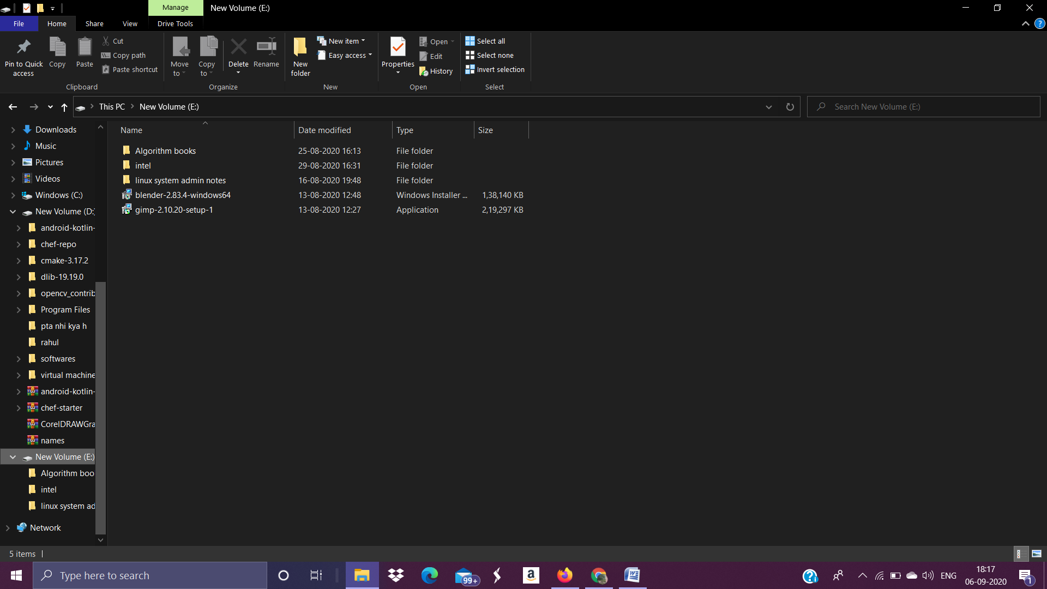

**Step 3:- Welcome screen will appear click next:-**

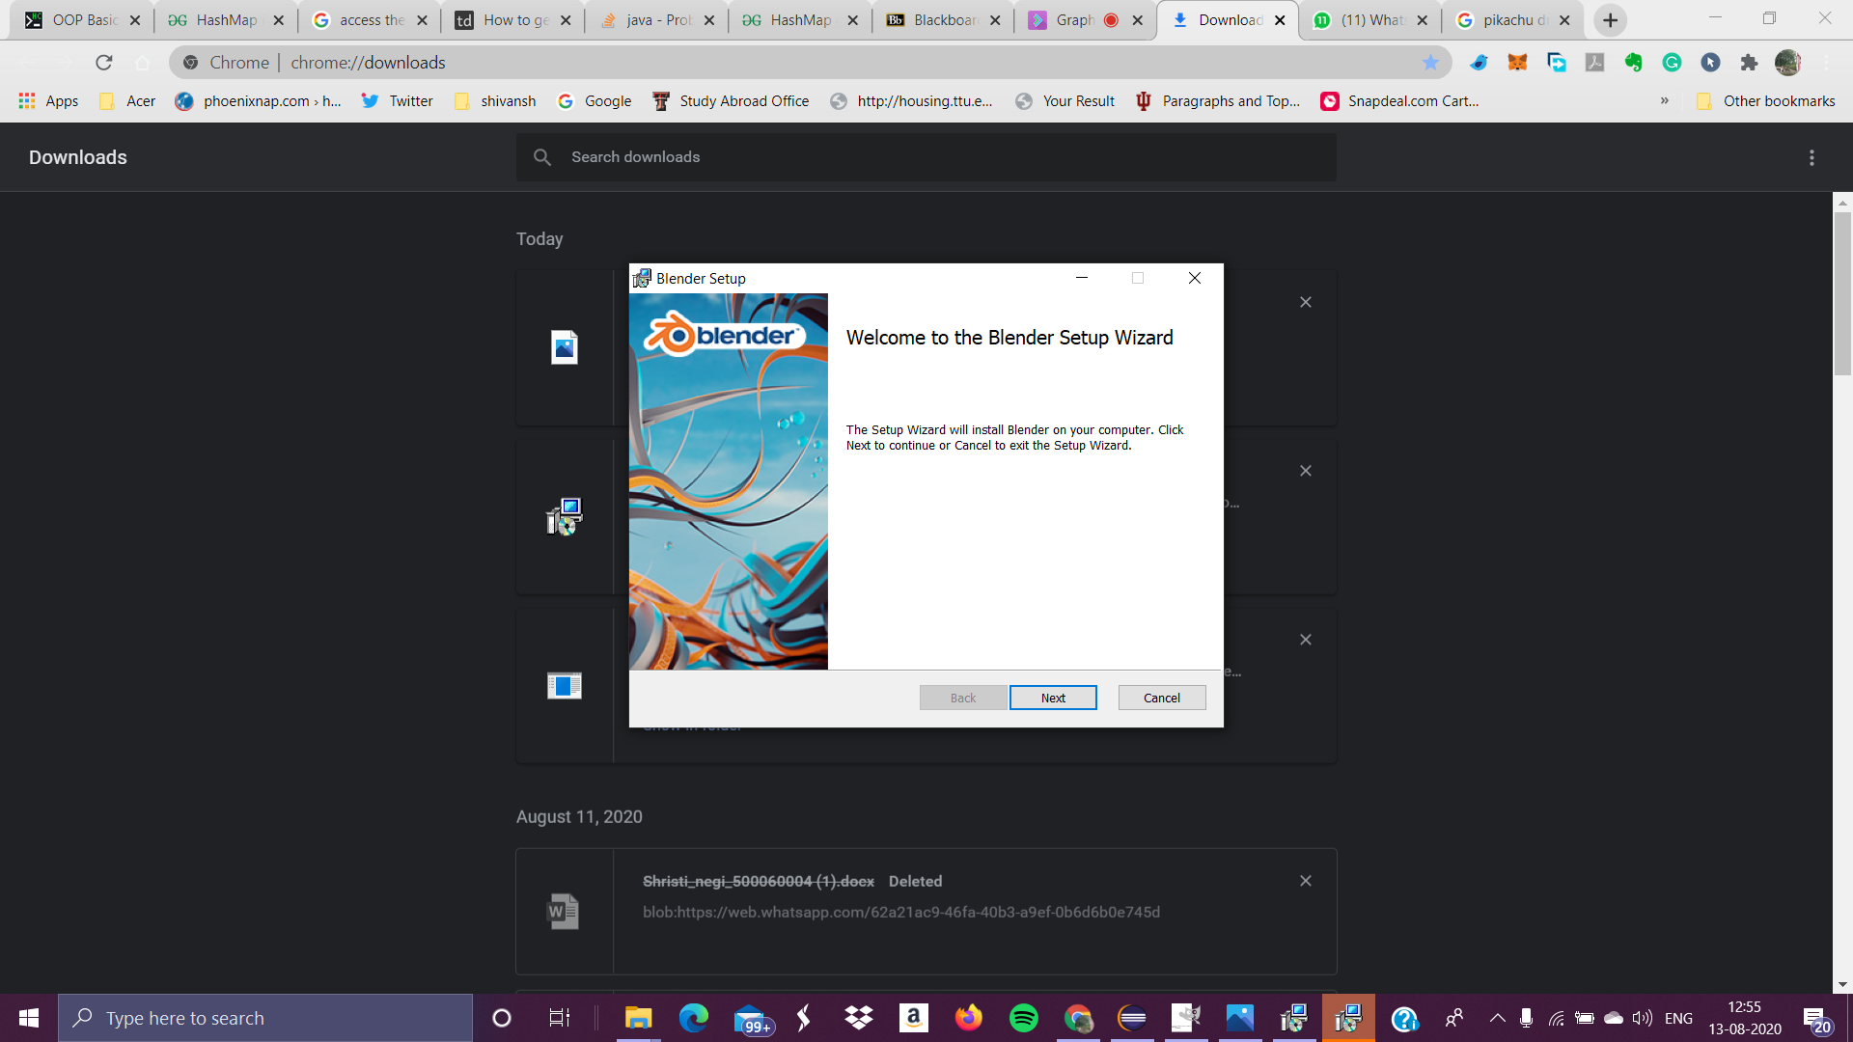

Step 4:- Click next by accepting the end user license agreement

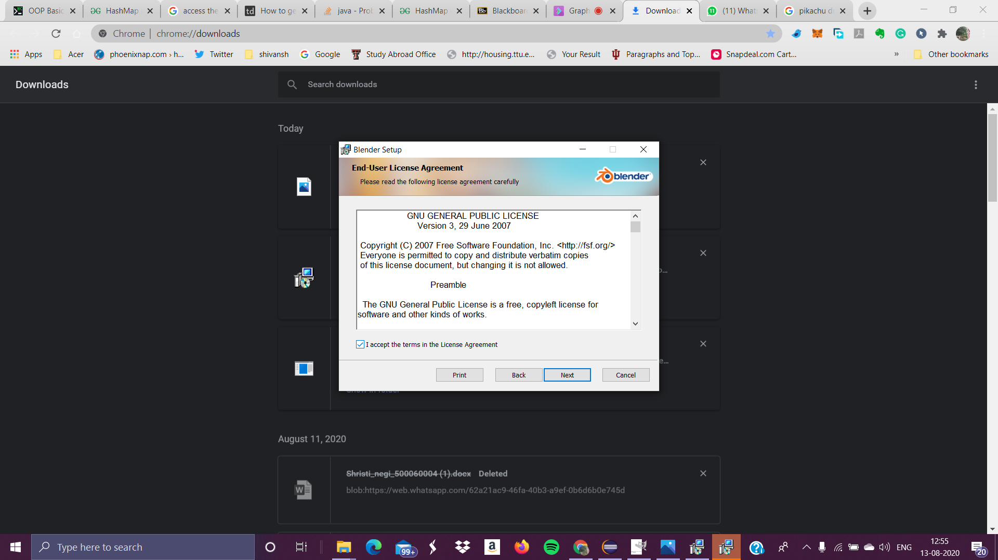

Step 5:- Select the drive and click next

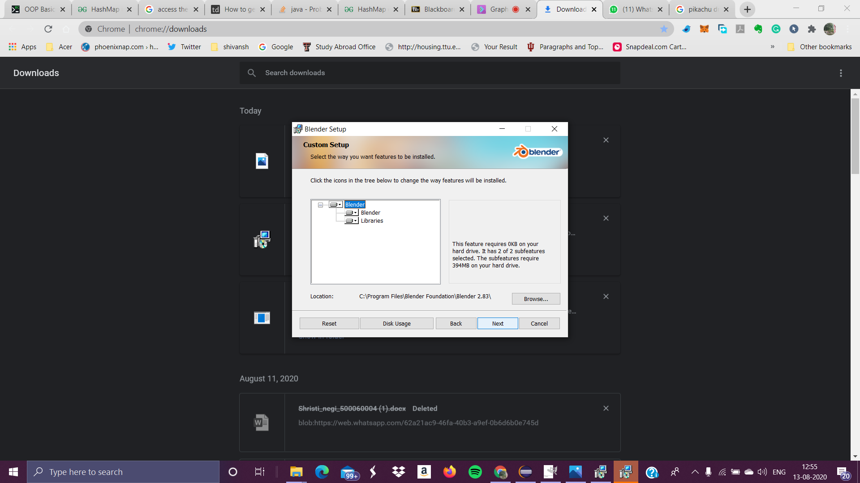

Step 6:- Now Blender is ready to install click the install button

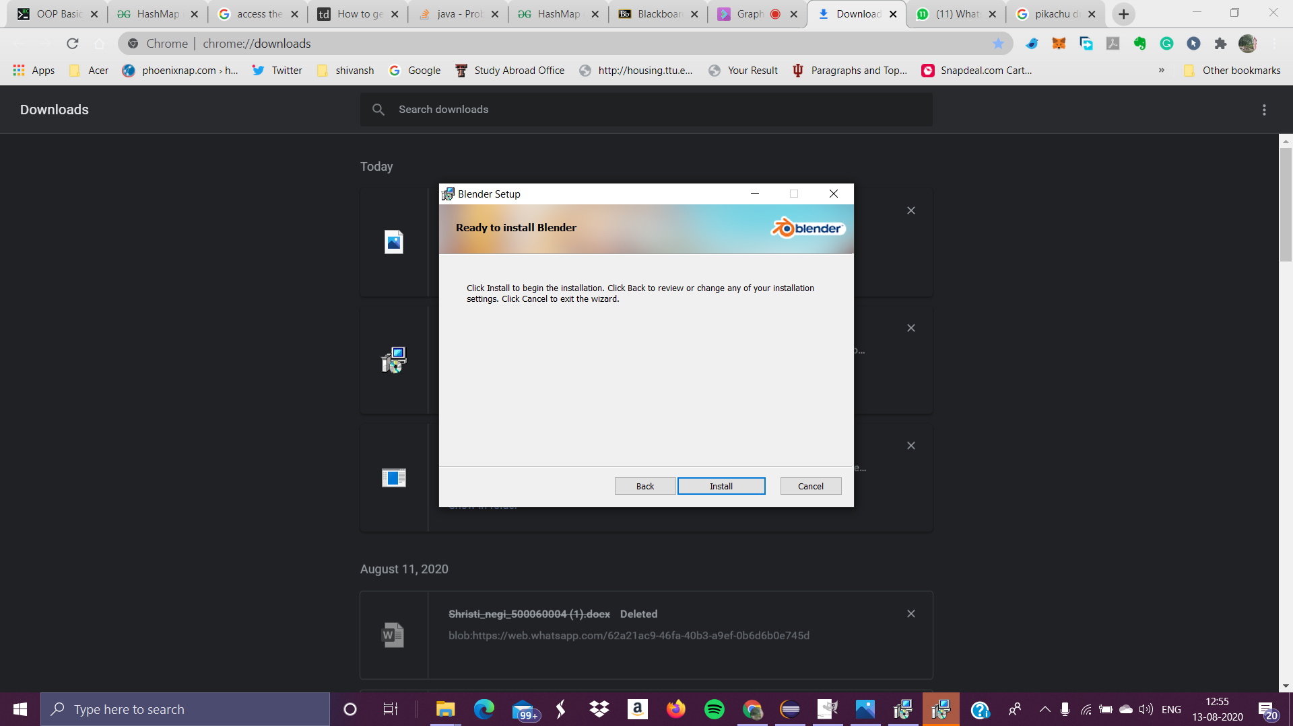

GIMP installation in windows:-

Step 1:- Download the GIMP setup from the <https://www.gimp.org/downloads/>

Step 2:- After downloading the setup click the setup for installation:-



Step 3:- Select the language:-

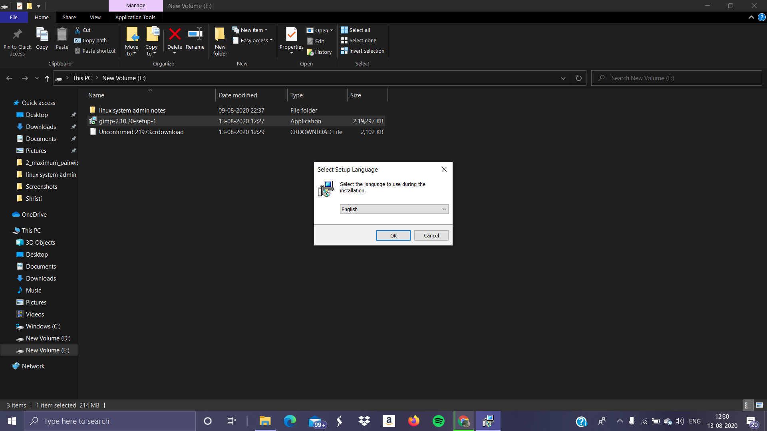

Step 4:- Click the button install

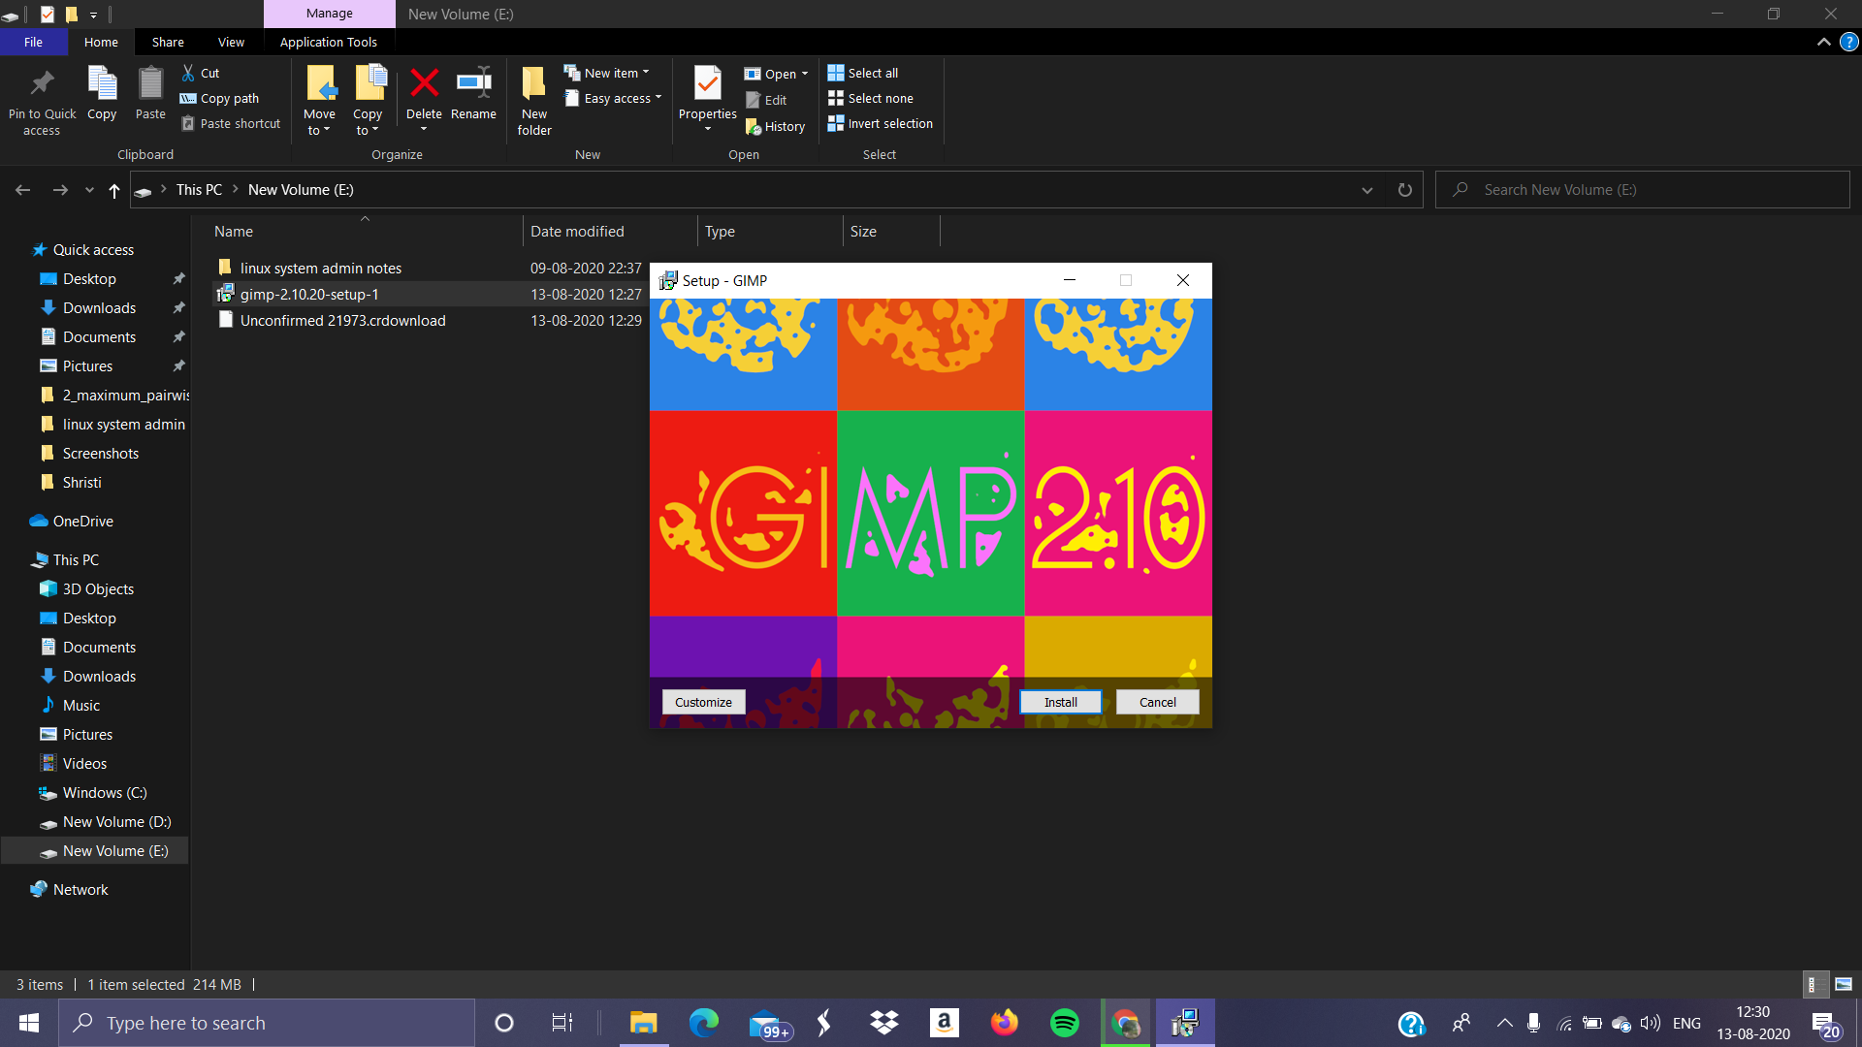

Step 5:- Installation is start and files are start downloading:-

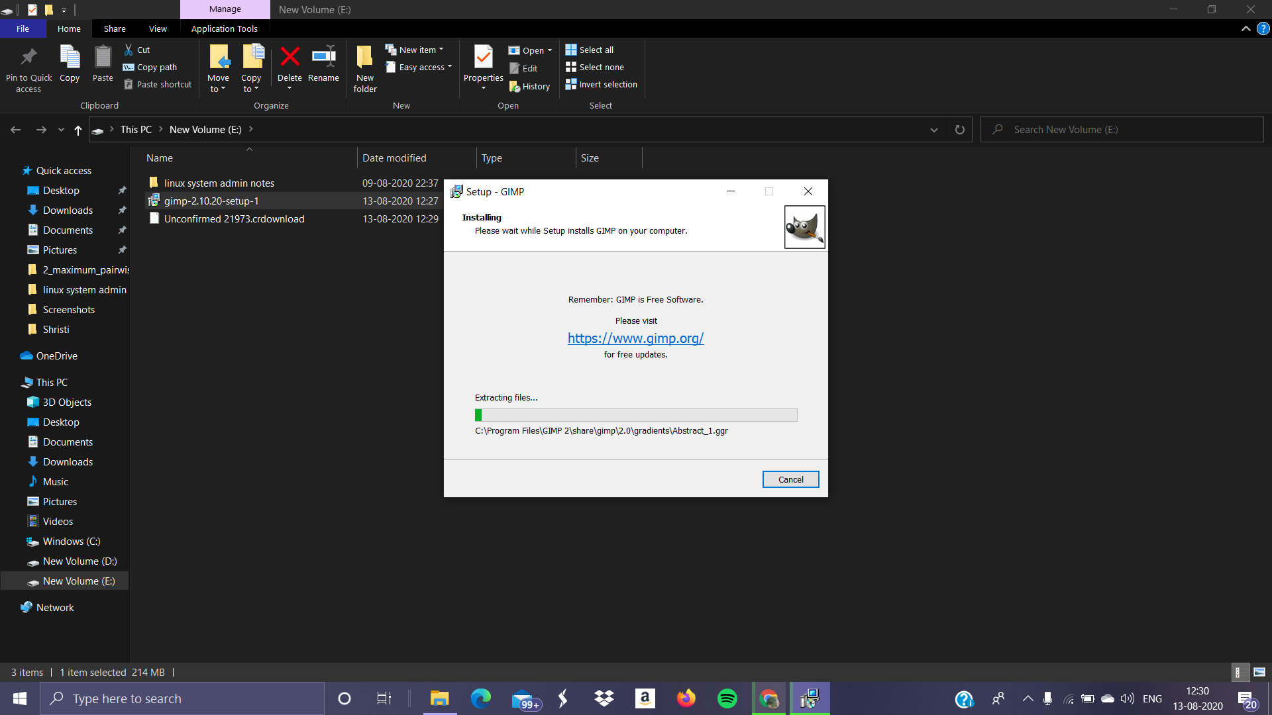

Step 6:- After downloading the all files click the finish button:-

